HIGH COURT OF UTTARAKHAND AT-NAINITAL
www.highcourtofuttarakhand.gov.in
email- highcourt-ua@nic.in
Telephone No. 05942-233826

Tender Notice
Dated: 28.09.2022
Subject: Notice inviting tender for repair & maintenance of Steel & wooden furniture items.
The High Court of Uttarakhand, Nainital invites sealed tenders from competent Firms/Agencies for repair & maintenance of steel & wooden furniture items at High Court of Uttarkhand, Nainital campus. Proposals are required to be submitted in a sealed covers addressed to the Registrar (Protocol), High Court of Uttarkahnd at Nainital- 263001 so as to reach us on or before 13.10.2022 up to 3.00 pm, duly super scribing the work i.e. “Tender for repair & maintenance of steel & wooden furniture items” on top of the cover. Bidders should read the tender documents carefully as enclosed and comply strictly with conditions, while sending their bids. Clarifications, if any, may be sought from the Management Section, High Court of Uttarakhand, Nainital on Telephone No. 05492-233826. Tender format and terms & conditions can be downloaded from our website www.highcourtofuttarakhand.gov.in.

S/d
Registrar (Protocol)

TENDER DOCUMENT FOR REPAIR & MAINTENANCE OF FURNITURE
AT HIGH COURT OF UTTARAKHAND, NAINITAL
1. Scope of Work
- Repair & maintenance of steel & wooden furniture items is to be carried out in the premises of High Court of Uttarakhand, Nainital and only electricity will be provided for the said work by the Court.
- Any loss or damage of any item during repair & maintenance within the premises of the High Court, the Bidder shall be liability of the Bidder and High Court, at its discretion, will deduct cost of the lost/ damaged item or any part thereof from the bill of the Bidder.
- The Bidder shall use materials of standard quality for repair & paint of furniture.
- The Bidder shall use fabric & foam on the chairs according to earlier fitted material.
- The Bidder shall initiate, job card for each repair job undertaken by him. The card should be got signed by Management Section official concerned after satisfactory completion of work.
2. Eligibility Conditions:
The Bidder should have PAN No. and GST No. and should submit their legible attested copies with Bid. The Bid not accompanied by these documents would be summarily rejected.
3. Preparation and Submission of Tender:
- Tender shall be submitted in official tender form only (Annexure- I, II & III). If submitted in any other form, the same shall be summarily rejected.
- Envelope must contain address of the Bidder, and should be super scribed with the statement “Tender for repair & maintenance of steel furniture items”.
- The tender must be sent by post to Registrar (Protocol), High Court of Uttarakhand, Nainital-263001 or submit at the office Management Section, High Court of Uttarakhand, Nainital.
- The tender will be submitted before 3:00 PM on 13.10.2022.
- Any tender form with any correction, amendments, overwriting etc. shall be considered invalid and shall be rejected, except if duly initialed with seal of the Bidder.
- The tender is liable to be rejected if complete information is not given therein, or if the particulars and data (if any) asked for in the tender are not filled in. Quoting rates for all the items is mandatory.
- The quoted rates shall include all taxes, duties etc. as applicable and no extra shall be payable on this account.
- The Bidder should also submit an undertaking regarding blacklisting, as given in Annexure II.
- The tender document should be duly signed on each page.
- Quoting rates for all the items is mandatory in Annexure-III and quoted consolidated lowest price shall be final and payable.
4. Site Inspection:
The Bidder can inspect the site after taking prior approval between 10 am to 5 pm on all working days to see the items required to be repaired. Management Section may be contacted on Telephone No 05942-233826 for this purpose. High Court will not be responsible for unawareness of facts.
5. Tender Fee and Earnest Money Deposit (EMD):
- The Tender must be accompanied by Tender fee of Rs. 590/- (non-refundable) submitted in the form of Demand Draft/ Banker’s Cheque drawn on any Scheduled Bank in favour of “Registrar General, High Court of Uttarakhand” payable at Nainital.
- The Tender must be accompanied by Earnest Money Deposit of Rs. 5,000/- (refundable) submitted in the form of Demand Draft/ Banker’s Cheque drawn on any Scheduled Bank in favour of “Registrar General, High Court of Uttarakhand” payable at Nainital.
- The EMD of unsuccessful Bidders will be discharged/ returned to them after placing of the order to the successful Bidder.
- Earnest Money is required to protect the High Court against the risk of the Bidder’s conduct, which would warrant the forfeiture of the EMD. Earnest money of a Bidder will be forfeited, if the Bidder withdraws or amends its tender or impairs or derogates from the tender in any respect within the period of validity of its tender.
- The successful Bidder’s EMD will be forfeited without prejudice to other rights of the High Court, if it fails to furnish the required Security Deposit within the specified period.
- No interest will accrue on the EMD/ Security Deposit.

6. Criterion for Evaluation of Tenders:
- The evaluation of the tenders will be made on the basis of submission of all technical and finanical information in tender bid. Incomplete bids, or those not supported by necessary documents shall be rejected.
- The tender shall be awarded on the total value of all the items.
7. Security Deposit:
The Bidder selected would be required to furnish a Security Deposit equal to 5% of the cost of the supply order in the form of Demand Draft/ FDR/ Bank Guarantee from any Scheduled Bank in favour of “Registrar General, High Court of Uttarakhand, Nainital” payable at Nainital. In case the Security Deposit is submitted in the form of Bank Guarantee, the same should be valid for a period of 06 (six) months beyond the date of expiry of the contract. High Court reserves the right to ask for performance guarantee extension if contractual obligations are not fulfilled.
8. Term & conditions:
- The work must be completed within 45 (forty five) days from date of issue of the supply order. All repairing work will be carried out in the premises of High Court of Uttarakhand, Nainital and only electricity will be provided for the said work by the Court.
- All statutory obligations under various laws from time to time shall be borne by Bidder for which no extra payment shall be made at any time during the contractual period.
- The Bidder shall at all times indemnify and keep indemnified for its employees and against all third party claims whatsoever (including time and shall not be limited to property loss and damages, personal accidents, injury or death of persons or servants or agents of any Bidder/sub- Bidder) and the Bidder shall at his own cost and initiative at all time, maintain all liabilities under Workman’s Compensation Act, Fatal Accident Act, Personal Injuries, Insurance Act and/or any other relevant Industrial Legislation, which is in force from time to time.
- High Court may terminate the contract without any notice in case the Bidder commits a breach of any of the terms of the contract. High Court decision that a breach has occurred will be final and shall be accepted without demur by the Bidder.
- The Bidder shall not assign or sublet the work or any part of it to any other person or party.
- Payment shall be made through NEFT transfer only and TDS as applicable will be deducted, after satisfactory completion of work.
- No advance payment will be made.
- All legal disputes shall be subject to the jurisdiction of Nainital Courts only.

S/d
Registrar (Protocol)

Technical Bid
Annexure-I
1 | Name
2 | Postal address of Vendor
3 | Telephones & Mobile No.
4 | E-mail
5 | PAN No. (Attach Copy of Certificate)
6 | GST No. (Attach Copy of Certificate)
7 | Details of Earnest Money Deposit (DD/ FDR/ Bank Guarantee No.)
8 | If any, Work Experience of manufacture, repair & maintenance of furniture items carried out in a Central/ State Government/ PSU/ Reputed private organizations. Enclosed the copy.

Annexure II
UNDERTAKING
It is certified that I/ my Firm/ Agency/ Company has never been black listed by any of the Departments/ Autonomous Institutions/ Reputed Educational Institution/ Public Sector Undertakings of the Government of India or Government of NCT of Delhi or any other State Government and no criminal case is pending against the said firm/ agency as on ___________.

Signature of the Bidder …………………………………………………
Name of the Signatory…………………………………………………..
Name of the Firm/Agency……………………………………………..
Seal of the Firm/Agency………………………………………………..
Place:…………………………………………………………………………
Date:…………………

Annexure III
Financial Bid
Price Bid for Furniture repairing work
SN | Description  Repairing Work | Qty.  (approx.) | Per Unit Rate | Total Cost | Remark
1 | Welding work for fixing of legs & handles on Steel Bench | 42 nos.
2 | Re-painting work on rusted condition Steel Bench | 31 nos.
3 | Fixing New Legs in steel bench (per pair) | 02 nos.
4 | Cast Iron Bench renovation (changing of wood strip and paint, Size about 5 feet) | 06 nos.
5 | Painting work on Cast Iron Bench | 12 nos.
6 | Painting work on Steel Almirah | 12 nos.
7 | Painting work on Steel Bookcases | 31 nos.
8 | Fixing new Handle in Steel Almirah | 08 nos.
9 | Fixing new Handle in Steel Book Case | 04 nos.
10 | Changing Lock in Steel Almirah | 10 nos.
11 | Doors Setting in Steel Almirah/Bookcase | 06 nos.
12 | Godrej Visitor Chair (model: PHC-7003) fabric changing work according to earlier fitted fabric (Color: Red) | 40 nos.
13 | Handle change of the Godrej Visitor Chair (model- PCH-7003) | 20 Pcs.
14 | Wooden Chairs renovation (Polish, new fabric (leatherette) & foam fixing on back & seat of the chairs) | 20 nos.
 | Grand Total

Authorized Signature :
Name & Designation :
Place :
Date :

Steel Almirah
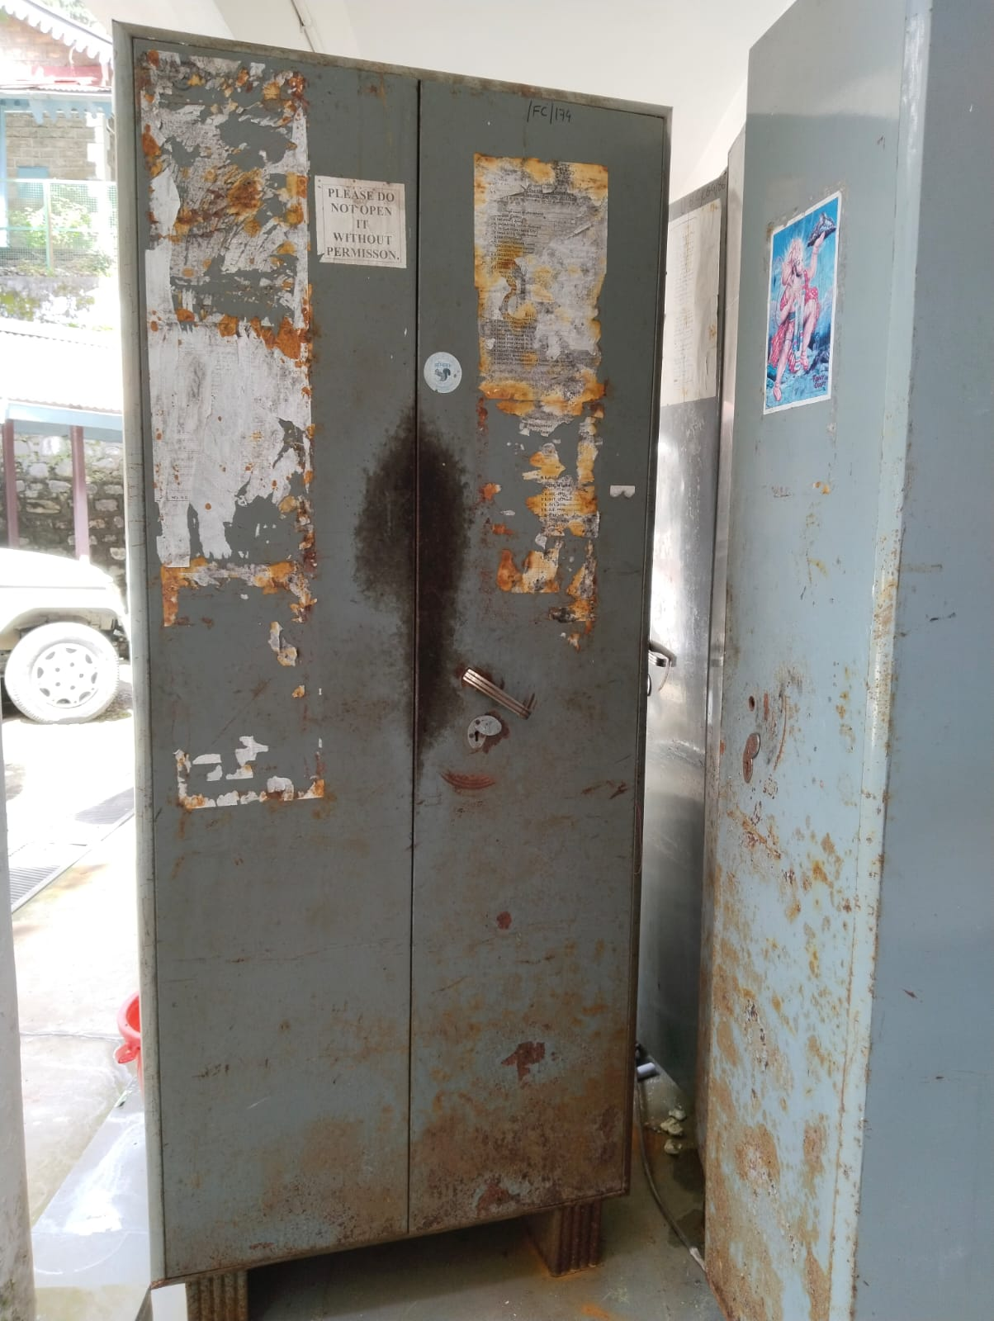
Steel Bookcase
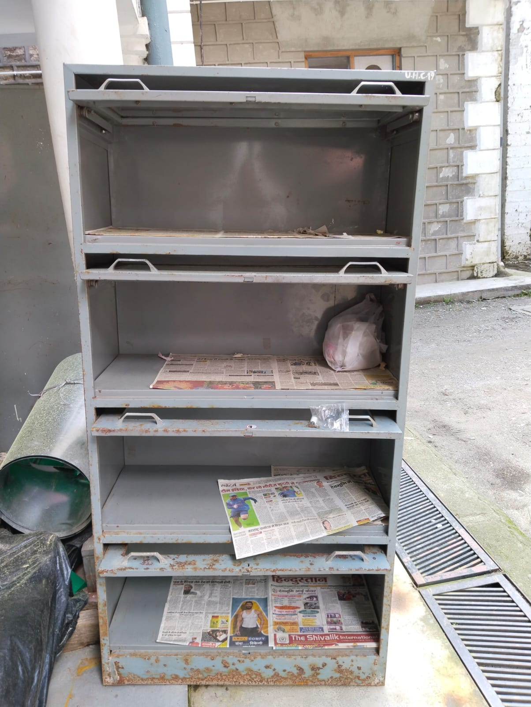

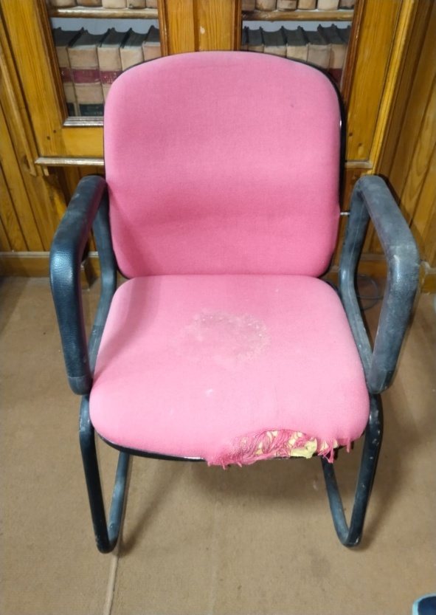  Visitor Chair (Godrej) | 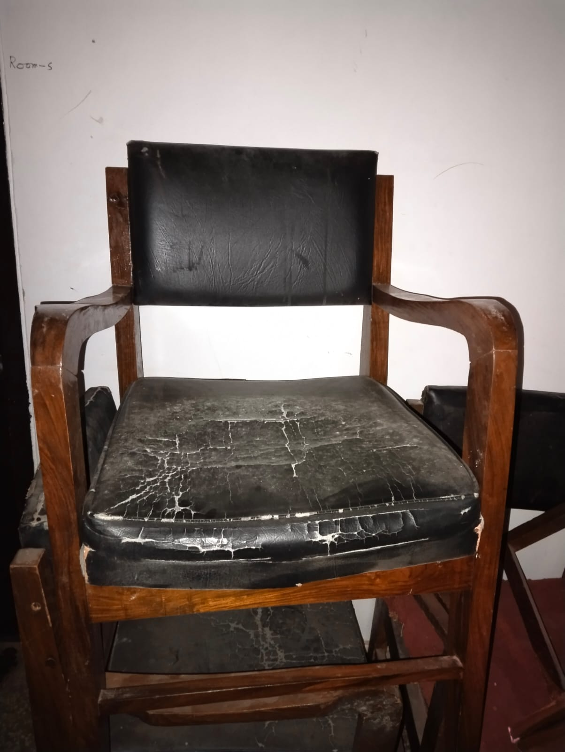  Wooden Chair (with fixed Cushion)

Cast Iron Bench (back & seat wooden)
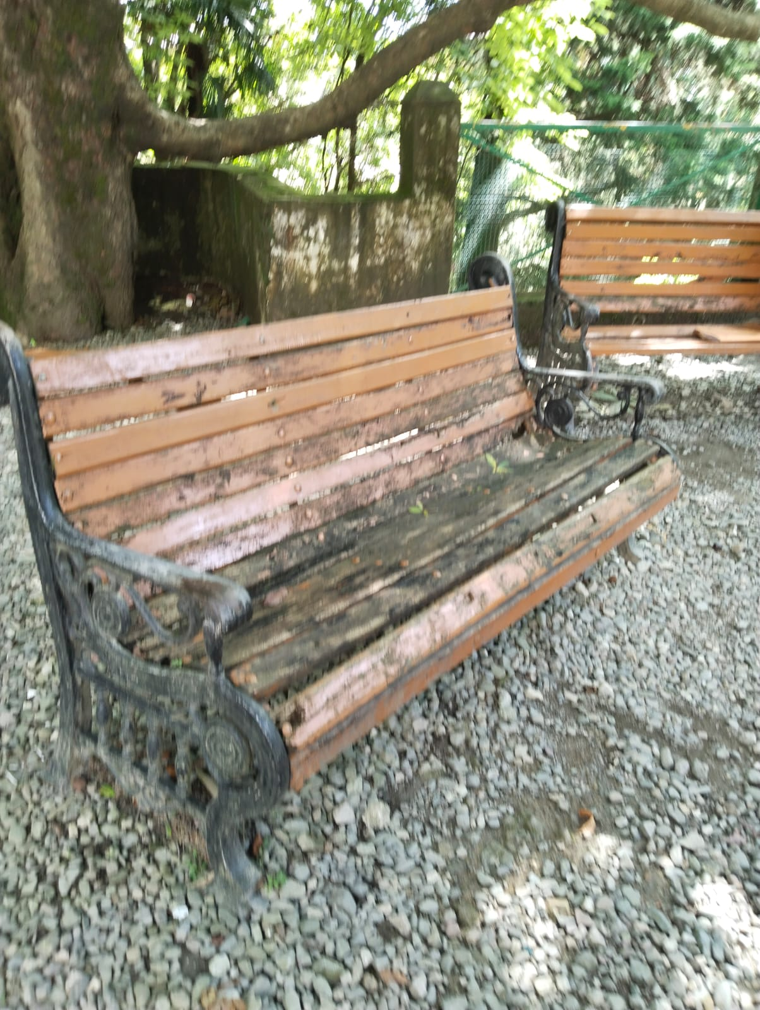

Steel Bench
